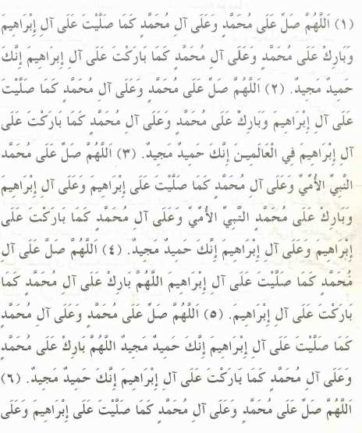
Page: 1 / 7 | By:I.C.F

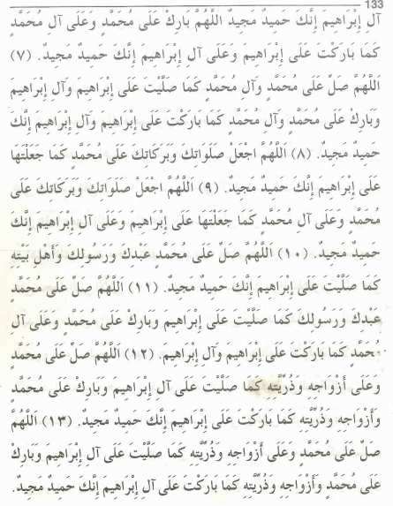
Page: 2 / 7 | By:I.C.F

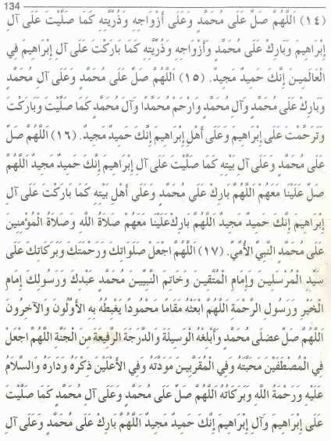
Page: 3 / 7 | By:I.C.F

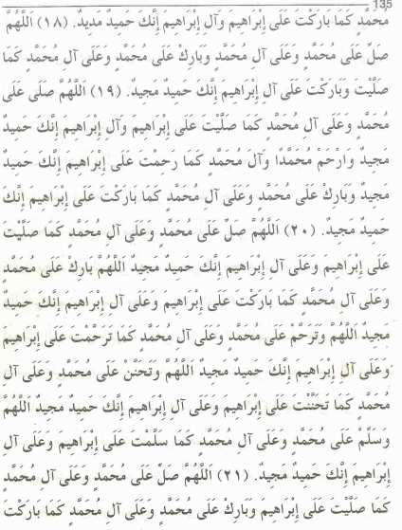
Page: 4 / 7 | By:I.C.F

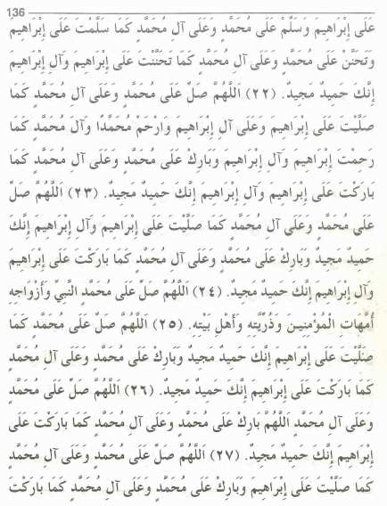
Page: 5 / 7 | By:I.C.F

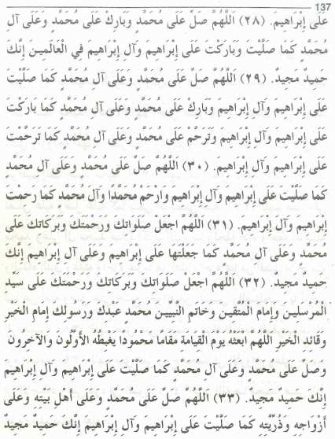
Page: 6 / 7 | By:I.C.F

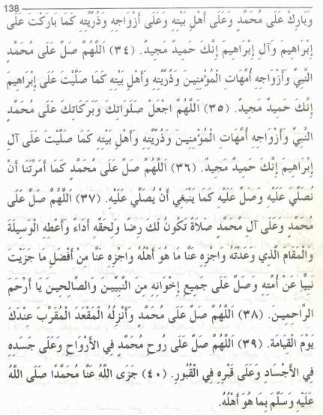
Page: 7 / 7 | By:I.C.F

